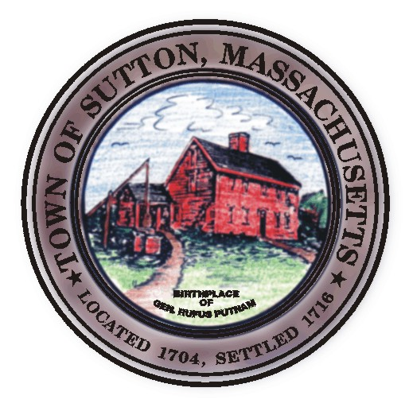

TOWN OF SUTTON ZONING BOARD OF APPEALS
4 UXBRIDGE ROAD · SUTTON, MA 01590 · (508) 865-8723 · FAX (508) 865-8721

ZONING BOARD OF APPEALS
MINUTES
March 6, 2014

Approved by: ________________

Date: _______________________

Board members Present: Richard Deschenes; Jeffrey Fenuccio; Brittanie
Reinold, Richard Haskins, Nicole Kuchinski, Associate Member
Secretary: Lynn Dahlin
All others present: Alan J. Murray; Paul Hutnak, Andrews Engineering

7:30pm – Public Hearing
26 Mallard Way
Alan Murray
Board Members: RD, JF, MM, RH, BR, NK
R. Deschenes read the hearing notice as it appeared in the Millbury Sutton Chronicle.
The petitioner requested a Finding from the Board that the tear down and rebuilding of one of the two Single Family Homes located on the non conforming property would not be any more non-conforming than the existing Use to the neighborhood.

Paul Hutnak spoke for the applicant and explained that the plan was to raze the (900) +sq.ft. house which was built in 1925 and replace it with a (1590) sq.ft. home. The home would be located in the same vicinity and would have a wooded Buffer up against the abutting property owned by the McNamara’s and would be no closer than the location of the existing home toward the abutting property owned by the Salem’s. It was also noted that they already had their approval from Conservation.
(Arrival of Richard Haskins)
Mr. Hutnak provided a brief overview of the project for R. Haskins.
R. Deschenes asked if they had plans of what would be built and was told it would be a two (2) level log home.
J. Fenuccio requested clarification of the square footage and was told that the foundation would be (1590) sq. ft in size. Alan Murray added that the living space would be about (2000) square feet as it was a two bedroom home with a loft area.
M. McGovern requested verification that no setback or lot coverage variances would be necessary and that the project was just an expansion of the footprint which was confirmed by Alan Murray.

J. Fenuccio questioned if there were plans to rebuild or expand the second residence of which it was explained that there were no current plans to do so though it was expected that there would be sometime in the future. J. Fenuccio was concerned with the second residence and the affects of that expansion and P. Hutnak noted that with the project in currently in front of the Board they were still only at 3.4% lot coverage. J Fenuccio replied that the Board just needed to be aware that they were making a finding and

that the finding would not be on the full project. It was felt that the future expansion of the second home could involve a request for an even larger home that could in fact be found to be more detrimental and he wanted the petitioner and his brother to be aware ahead of this ahead of time so that there were no potential “We should have done this or could have done that” conversations.

R. Haskins asked whether the second residence was used as a primary residence and was told that it was currently being used as a summer home.

All those present in favor or opposition: None
Site inspection scheduled for Saturday March 8, 2014 at 7:30pm.
M. McGovern motioned, R Haskins seconded and the vote unanimous to continue the hearing to April 3, 2014 at 7:30pm.

Board Business:

R. Deschenes stepped down from the Board for the Leland Hill Estates discussion.

Leland Hill Estates: Comprehensive Permit
Board Members: JF, MM, RH, BR, NK
J. Fenuccio informed the Board that the Surety agreement document signed by the Board in December 2013 needed to be re-approved because the incorrect bank institution had been provided as well as an incorrect WDRD Book and page.
Nicole K. motioned and M. McGovern seconded to amend the Surety Agreement signed by the Board on December 23, 2013 to read “Amendment to Surety Agreement at Book 51202 Page 263” and “between the Town of Sutton, Leland Hill Estates, LLC and Middlesex Savings Bank. The remainder of the document remains the same.
Vote: 5-0-0 in favor

R. Deschenes rejoined the Board

Review of Minutes:
M. McGovern motioned, R. Haskins seconded, and the vote unanimous to accept the January 2, 2014 Minutes as written.

J. Fenuccio motioned, R. Haskins seconded, and the vote unanimous to accept the February 6, 2104 Minutes as written.

7:45pm -Meeting Adjourned

Respectfully submitted,

Lynn Dahlin
BOA Secretary

